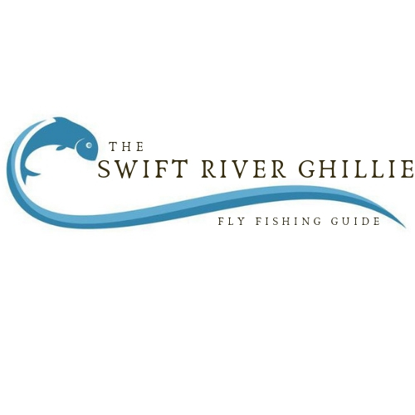

PARTICIPANT AGREEMENT, RELEASE AND ASSUMPTION OF RISK
(Please print) Name ___________________________________________________
Date ________________________
Street ________________________________________________________________________________ City _______________________________________ State ____________ Zip _____________________ Telephone Number ___________________________ E-mail ___________________________________
In consideration of the services of The Swift River Ghillie., their agents, owners, officers, volunteers, participants, employees, and all other persons or entities acting in any capacity on their behalf (hereinafter collectively referred to as the Swift River Ghillie), I hereby agree to release, indemnify, and discharge The Swift River Ghillie, on behalf of myself, my children, my parents, my heirs, assigns, personal representative and estate as follows:
1. I acknowledge that fishing from boats, float tubes, canoes, and while wade fishing entails known and unanticipated risks. Similar risks can be encountered while participating in wilderness navigation, hiking, and while using knowledge gained at any instructional session. These known and unanticipated risks could result in physical or emotional injury, paralysis, death, or damage to myself, to property, or to third parties. I understand that such risks simply cannot be eliminated without jeopardizing the essential qualities of these activities. The risks include, among other things: the hazards of walking on uneven terrain, slips and falls; drowning; becoming lost or injured in the woods; the risk of injuries caused by other boaters, fishermen, campers and hikers; the use of fishing and camping equipment; the forces of nature, including lightening, weather changes, and changing water levels; the risks of falling out of a boat or float tube; the risks of exposure to insect bites; the risk of the cold including hypothermia, frostbite, cerebral and pulmonary edema; my own physical condition, and the physical exertion associated with these activities. Furthermore, The Swift River Ghillie employees have difficult jobs to perform. They seek safety, but they are not infallible. They might be unaware of a participant’s fitness or abilities. They might misjudge the weather or other environmental conditions. They may give incomplete warnings or instructions, and the equipment being used might malfunction.
2. I expressly agree and promise to accept and assume all of the risk existing in these activities. My participation in these activities is purely voluntary, and I elect to participate in spite of the risks.
3. I hereby voluntarily release, forever discharge, and agree to indemnify and hold harmless The Swift River Ghillie from any and all claims, demands, or causes of actions, which are in any way connected with my participation in any of these activities or my use of The Swift River Ghillie’s equipment or facilities, including any such claims which allege negligent acts of omissions of The Swift River Ghillie.
4. Should The Swift River Ghillie or anyone acting on their behalf, be required to incur attorney’s fees and costs to enforce this agreement, I agree to indemnify and hold them harmless for all such fees and costs.
5. I certify that I have adequate insurance to cover any injury or damage I may cause or suffer while participating, or else I agree to bear the costs of such injury or damage myself. I further certify that I am willing to assume the risk of any medical or physical condition I may have.
6. In the event that I file a lawsuit against The Swift River Ghillie, I agree to do so solely in the state of New Hampshire, and I further agree that the substantive law of New Hampshire shall apply in that action without regard to the conflict of law rules of that state. I agree that if any portion of this agreement is found to be void or unenforceable, the remaining document shall remain in full force and effect.
The Swift River Ghillie PO Box 484 Conway NH 03818
Ability to Swim (please check one)
I CAN swim __________
I CANNOT swim __________
Are there any physical or mental conditions for which you are currently receiving medical treatment? Please include RECENT SURGERIES, PROBLEMATIC OLD INJURIES, any MEDICATIONS you are currently taking and all ALLERGIES. ______________________________________________________________________________________
______________________________________________________________________________________ ______________________________________________________________________________________ ______________________________________________________________________________________ ______________________________________________________________________________________ ______________________________________________________________________________________ ______________________________________________________________________________________ ______________________________________________________________________________________ ______________________________________________________________________________________ ______________________________________________________________________________________ ______________________________________________________________________________________ ______________________________________________________________________________________ _____________________________________________________________________________________
By signing this document, I acknowledge that if anyone is hurt or property is damaged during my participation in these activities, I may be found by a court of law to have waived my right to maintain a lawsuit against The Swift River Ghillie on the basis of any claim from which I have released them herein. I have had sufficient opportunity to read this entire document. I have read and understood it, and I agree to be bound by its terms.

Signature of Participant: ________________________________________
Print Name: ___________________________________________________
Fishing License Number if Applicable: _______________________________
Date:__________________________________________________________

PARENT’S OR GUARDIAN’S ADDITIONAL INDEMNIFICATION (Must be completed for participants under the age of 18) In consideration of ________________________ (print minor’s name) (“Minor”) being permitted by The Swift River Ghillie to participate in its activities and to use its equipment and facilities, I further agree to indemnify and hold harmless The Swift River Ghillie from any and all claims which are brought by, or on behalf of Minor, and which are in any way connected with such use or participation by Minor. Parent or Guardian: _______________________________
Print Name: ____________________________ Date: ______________________

PHOTO RELEASE AUTHORIZATION
I hereby grant to The Swift River Ghillie, and their respective licensees, successors and assigns, the right and permission, with respect to those photographs taken of me or the minor named below on whose behalf I am signing, and with respect to any printed matter in connection therewith, to do the following:
1. To include such photographs in all media, slide presentations, the advertising of, publicity, and promotion of The Swift River Ghillie. 2. To use my name or the name of the minor on whose behalf I am signing, in connection with the foregoing.
I hereby release, discharge and agree to indemnify and hold harmless The Swift River Ghillie and their respective heirs, legal representatives, licensees, successor and assigns, from all claims and demands whatsoever arising out of or in connection with the foregoing, and waive any right to inspect or approve the same.

__________________________________________
Signature of Subject of Photograph

_______________________________________________________________________________
Printed Name and Address.

I hereby certify that I am the parent and/or guardian of ______________________________, a minor under the age of eighteen years, and hereby consent on behalf of said minor to the use of any of the photographs taken of said minor pursuant to the terms set forth in this Photographic Release, including, without limitation, the release, discharge and hold harmless provisions thereof.

_______________________________________________
Signature of Parent or Guardian of Minor Subject of Photograph

__________________________________________________________________________________
Printed Name and Address

